Project Design Phase
Solution Architecture

Date | 2 October 2026
Team ID | SWTID-2026-6670
Project Name | Implement Client Script & UI Policy (Incident)
Maximum Marks | 4 Marks

Solution Architecture:
Solution architecture is a complex process – with many sub-processes – that bridges the gap between business problems and technology solutions. Its goals are to:
- Find the best tech solution to solve existing business problems.
- Describe the structure, characteristics, behavior, and other aspects of the software to project stakeholders.
- Define features, development phases, and solution requirements.
- Provide specifications according to which the solution is defined, managed, and delivered.
Solution Architecture Diagram: Incident data validation in ServiceNow
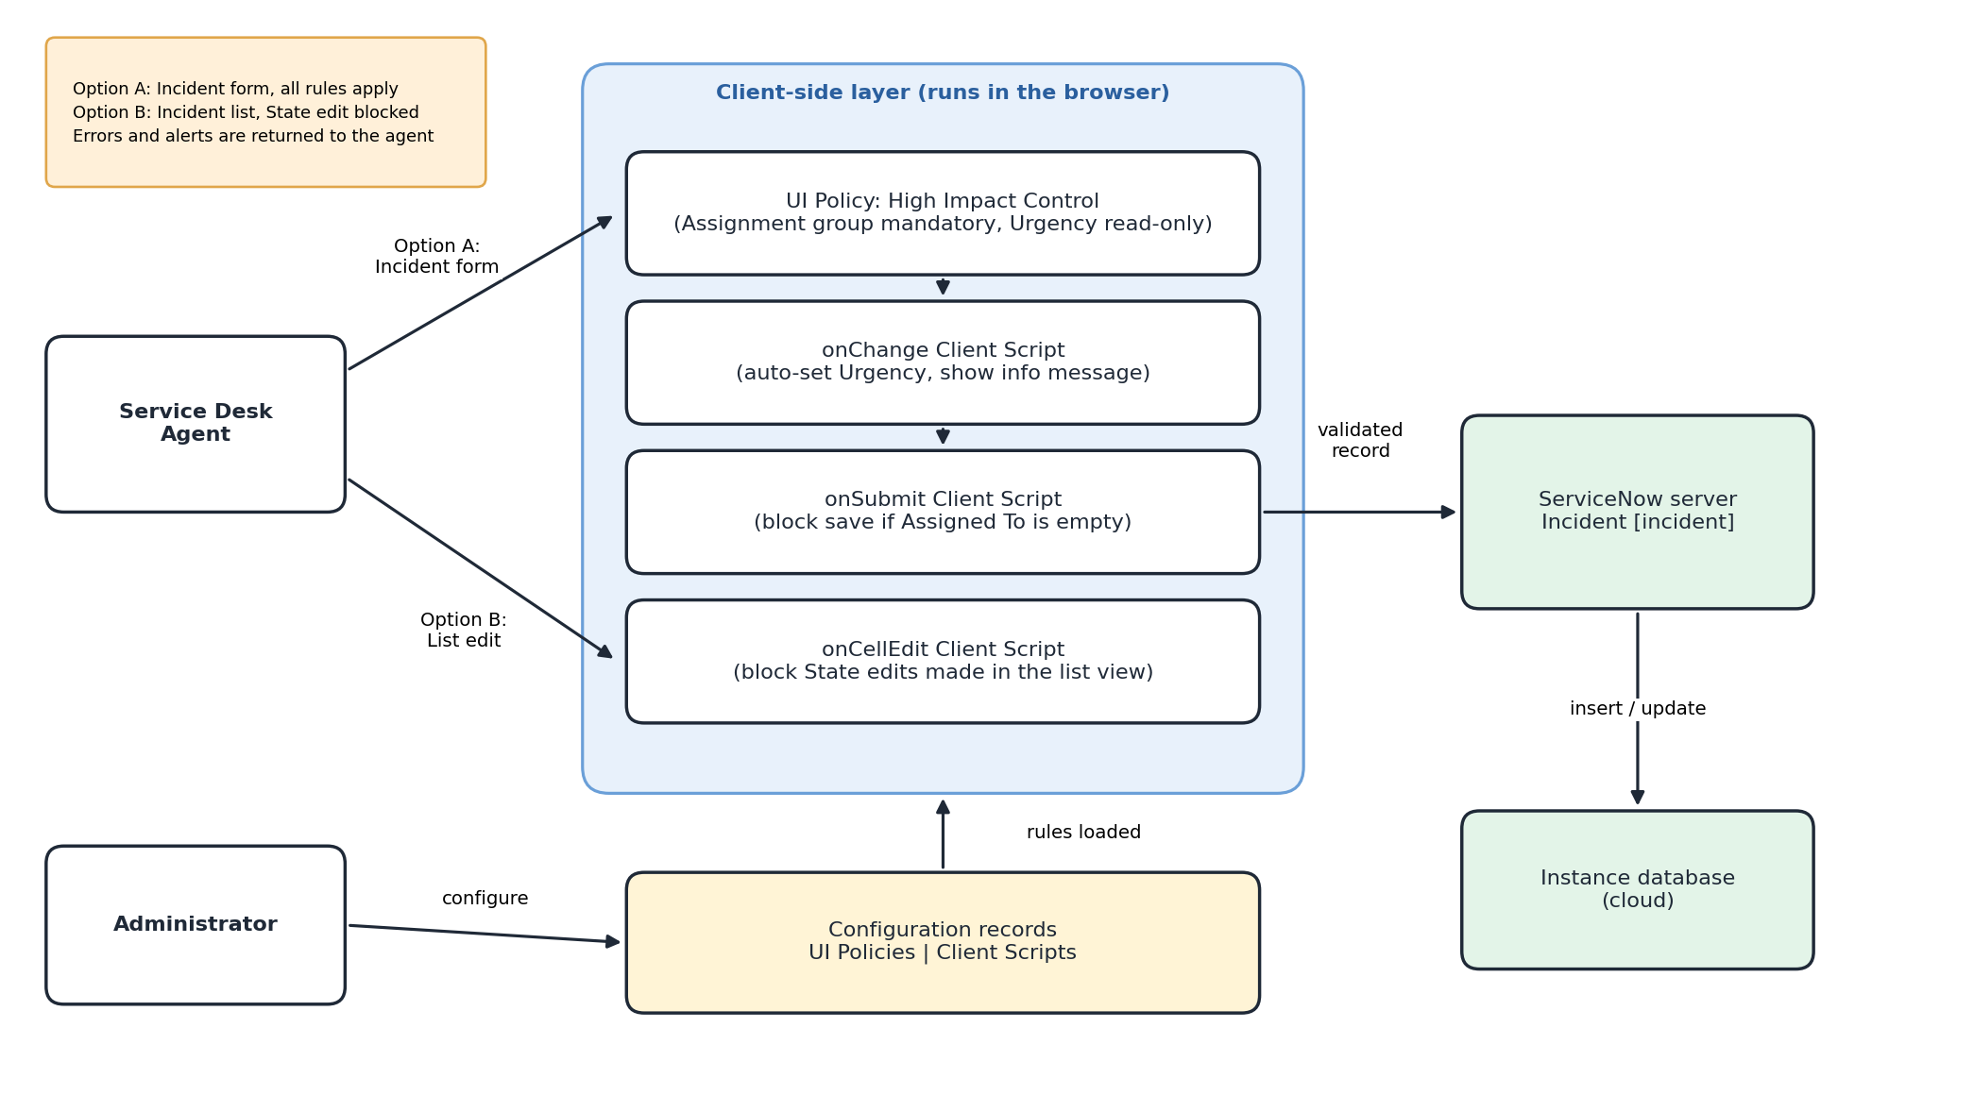
Figure 1: Architecture and data flow of the Incident Client Script & UI Policy solution
Architecture flow:
1. The Service Desk Agent works on the Incident form (Option A) or the Incident list (Option B).
2. On the form, the UI Policy makes Assignment group mandatory and Urgency read-only when Impact = High; the onChange script sets Urgency to High.
3. On save, the onSubmit script blocks the record if Assigned To is empty; in the list, the onCellEdit script blocks State edits.
4. Valid records are sent to the ServiceNow server, inserted or updated in the Incident table and stored in the cloud instance database.
5. The Administrator maintains the UI Policies and Client Scripts, which the browser loads at runtime.

